GitLab for EDW – Environment setup Handbook

**Environment Setup**

1. Get the below tools installed in VDI, by raising “[Software Request – IT Approved](https://svb.service-now.com/sp/?id=sc_cat_item&sys_id=209480be81283100af47e7e6ba9ca299)” form
   1. GitHub Desktop
   2. GitBash
   3. Git
2. Get access to EDW repo of Gitlab.

Once access request is in-place, kindly check, if the below URL is accessible. <https://code.gitlab.prod.us-west-2.tlz.svbank.com/edw/edw1>

**Establish SSH Connection**

SSH Connection is to be established by following the below steps.

Go to command prompt and change to home directory

Run the below command

ssh-keygen -t rsa -C "SSH Key Generation for GitLab"

Press Enter

Press Enter and enter again

A folder .ssh is created in the path C:\Users\uselvamani

In this folder, we see a file called id_rsa.pub

Open id_rsa.pub in Notepad++ and copy the contents of the file.

Open <https://code.gitlab.prod.us-west-2.tlz.svbank.com/edw/edw1>

Go to Preferences

Select SSH Keys from the left pane

Add the copied key into the Key Textbox and click on “Add key”

SSH Key is added as below

Test if SSH Connection is established

Go to <https://code.gitlab.prod.us-west-2.tlz.svbank.com/edw/edw1>

Select Clone

Copy the “Clone with SSH URL”

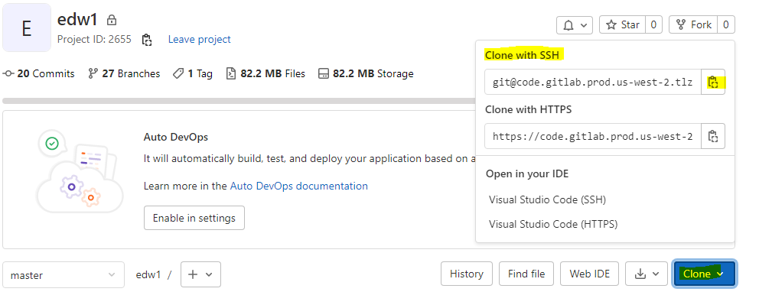

Go to GitBash and run the below command

cd C:\Users\uselvamani <<switching to home directory>>

git clone <<paste the url copied above>>

If the above command is complete successfully, then the SSH Connection is complete successfully.